

|  |  |
| --- | --- |
|  | Laboratory Exercise 2: Digital Image Correlation (DIC) Testing |
|  |  |
|  | Nguyen Xuan Binh (887799)  Amini Ehsan (Research assistant) |
|  | MEC-E6007 Mechanical Testing of Materials  26/03/2024 |
|  |  |

# Introduction

Digital Image Correlation (DIC) is an optical technique to measure deformation, displacement, and strain on materials subjected to mechanical loads. This non-contact method uses a high-resolution camera to capture sequential images of a specimen's surface as it undergoes stress. These images typically feature a speckle pattern—a randomly distributed, high-contrast pattern painted or applied on the surface of the material [1]. The DIC system then analyzes changes in this pattern using complex algorithms to compute full-field strain and displacement maps [1]

For this report, we documented the DIC testing conducted on DP800 material, using shear geometry in the preparation and execution stages. The material DP800, known for its high strength and ductility, is a dual-phase steel commonly used in automotive and structural applications where high performance under stress is required.

Our testing was conducted on April 25, 2024, in a controlled lab environment where we aimed to investigate the material behavior under tensile stresses across multiple specimen geometries—Shear (SH), Central Hole (CH), Notched Dob Bone (NDB), and Standard Dob Bone (SDB). Each geometry presents unique challenges and insights into the material properties, making DIC an ideal choice for its ability to provide detailed, localized measurements of deformation.

Unfortunately, due to scheduling conflicts, the post-processing stages were conducted on specimens with the central hole geometry instead of the initially intended shear geometry. Moreover, for reasons pertaining to data privacy, this report will primarily discuss extracted data from the notched dog bone geometry. Nevertheless, the methodologies and general procedures described herein are consistent and applicable across all tested geometries, ensuring that the findings are relevant and can be applied to similar tests on DP800 material.

There is a question that some beginners to DIC may ask is why we must apply a speckle pattern physically on the specimen (such as paint or stickers), instead of computer-generated pattern. The answer is that computer generated patterns simply do not know how it should change over the surface of the specimen to measure its local deformations. Physical speckles simply move along the surface during any deformation tests, telling us information about local strain and how the material deforms over time using image correlation.

There are three stages of DIC testing:

* First, we apply paints on the testing specimen as preprocessing
* Second, we apply the deformation test on the specimen and take pictures during the process
* Third, we postprocess the recorded images into DIC results and visualizations

# DIC testing: Preprocessing stage of applying paint speckles.

## 2.1 Material preparation

Firstly, the specimen preparation was critical to ensure accurate DIC results. The surface of the DP800 material was meticulously cleaned using acetone to remove any contaminants. It was crucial that the middle part of the specimen, where DIC paint would be applied, was not touched post-cleaning to avoid any smudges or residues.

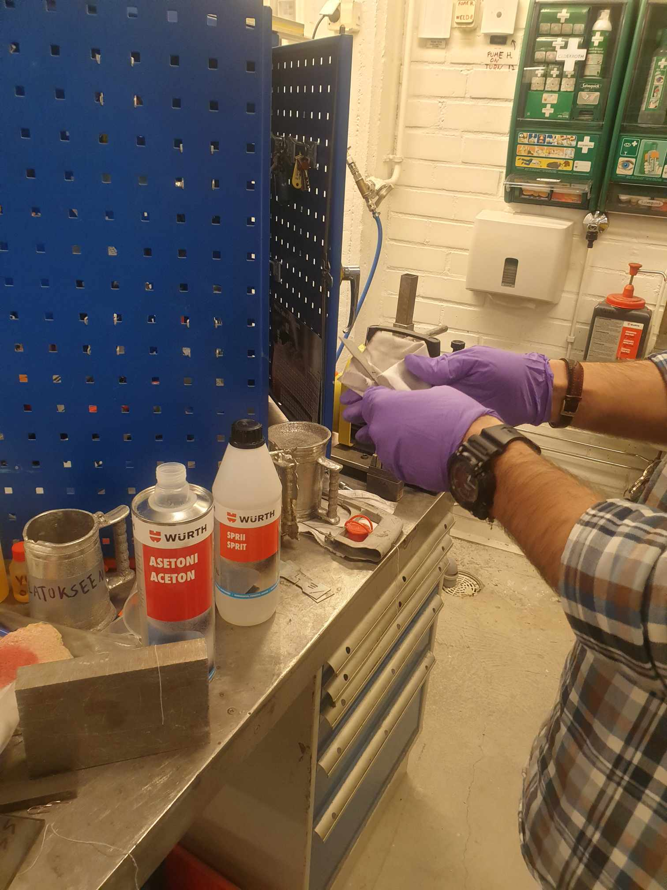

## 2.2 Painting process

General procedures

For DIC analysis, the specimen must have a contrasting speckle pattern. Initially, a white base coat was applied to the cleaned surface. After drying the base coat, a black speckle pattern was added. This speckling process was refined through trial and error to achieve optimal brightness for the DIC equipment, ensuring clear differentiation between speckles. If the speckle quality was found to be inadequate, acetol was used to remove the paint, allowing for a redo of the painting process.

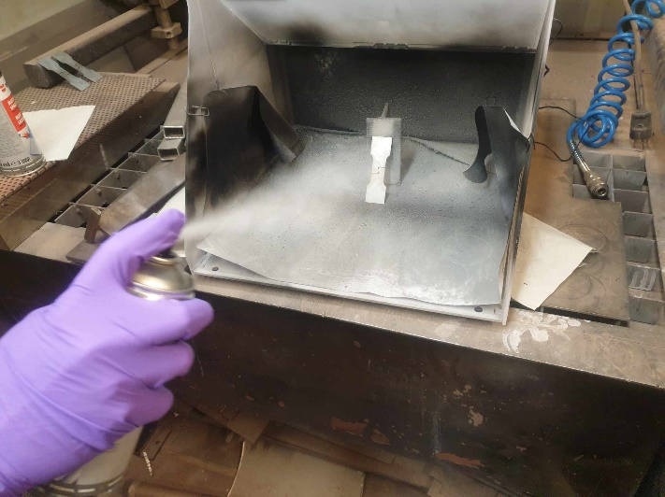

First, we apply the white paint on the specimen. We apply the white paint on the surface until it becomes very shiny and bright.

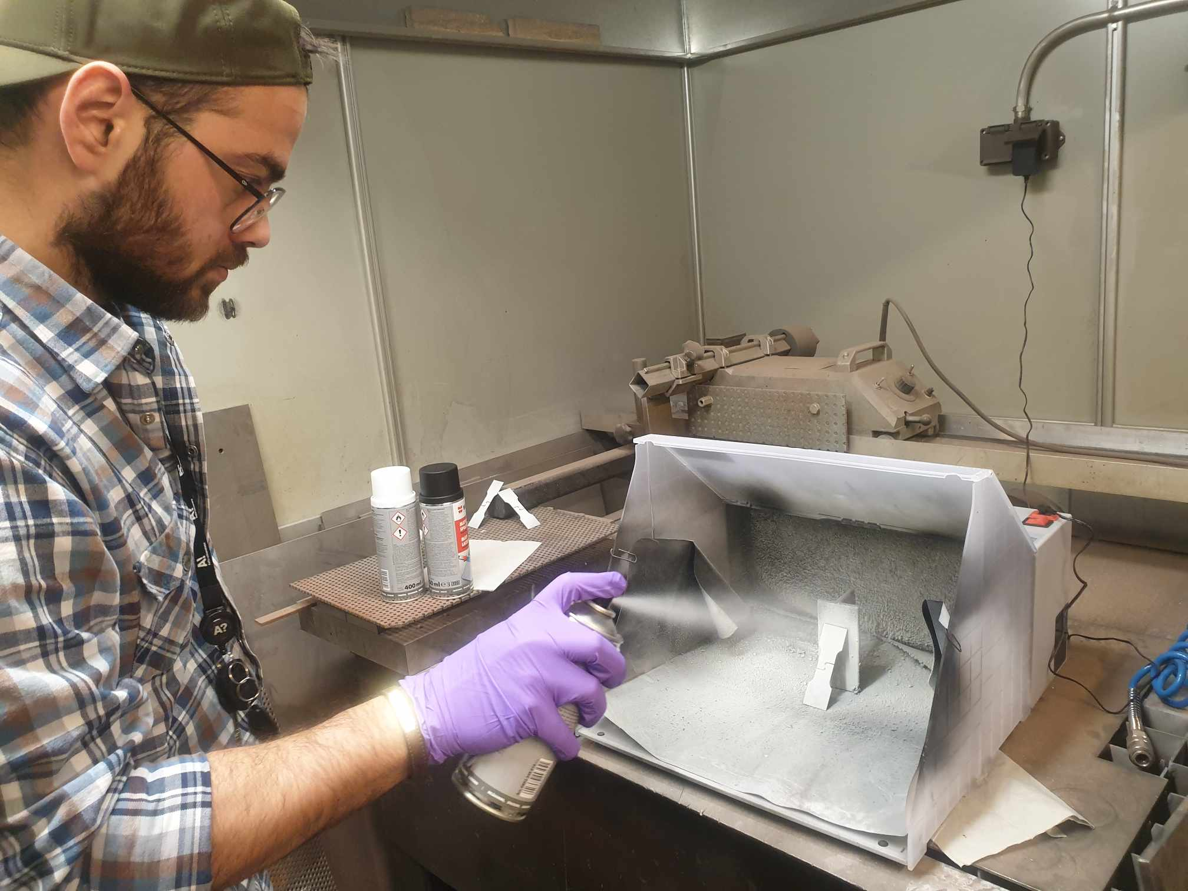

Next, we use black paint to spread intermittently on the specimen to make random noise speckles on the surface. We need to make sure that the speckles are well distributed along the surface without any dense or sparsely area of speckles. After painting, it is extremely crucial that we do not touch the middle part of the specimen, or we would ruin the images later during DIC.

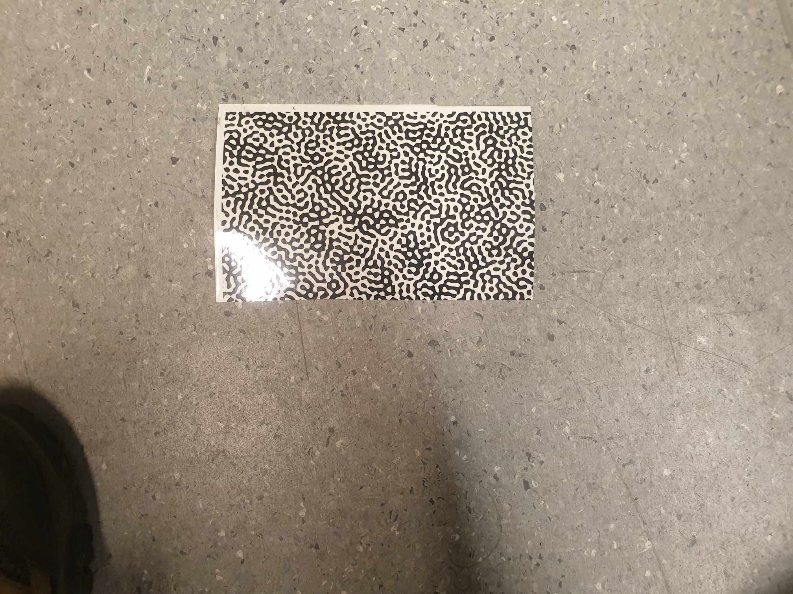

Besides using paint, we can also use computer numerical patterns, which can be glued onto the specimen. This is more common for larger machines or specimens where using paint is wasteful.

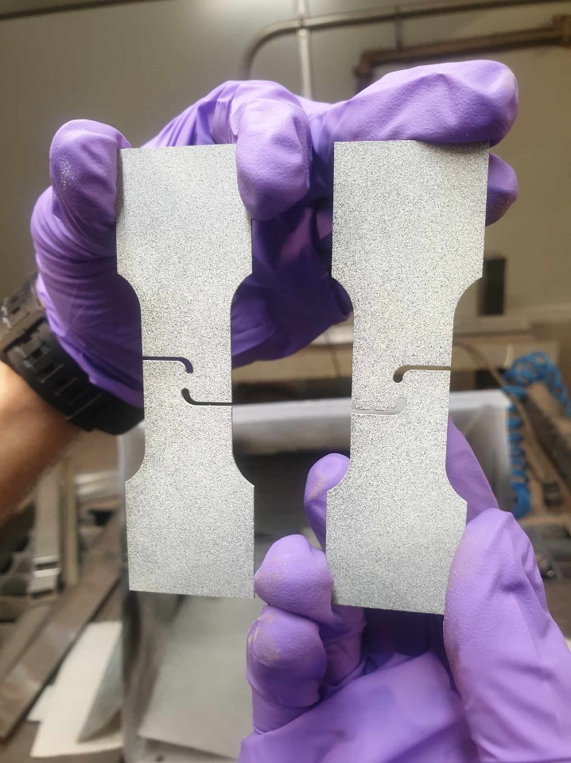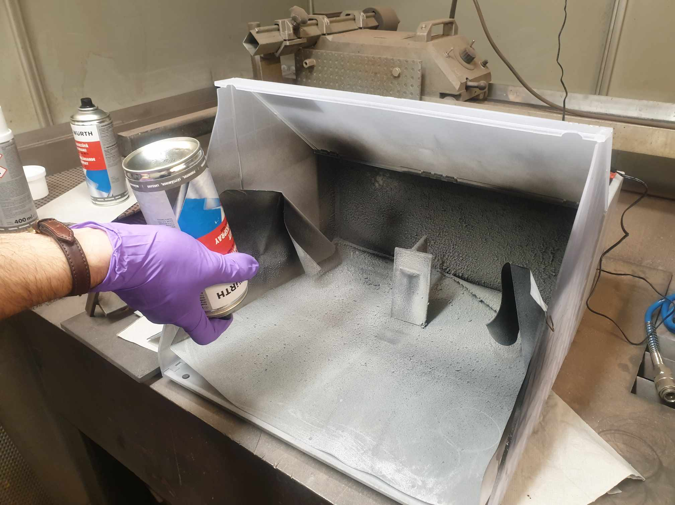

Comparison: on the left is bad patterns and on the right is good pattern for the two specimens

This is because the left specimen has too dense speckles at the center and sparse speckles at the rear end of the grip section. After we use paint, we need to press the bottle upside down and press the button to spurt out paint until no paint comes up to clear the nozzle of the paint. This would help make the paint bottle last longer without becoming stuck at the nozzle

# DIC testing: Recording images during tensile test

## 3.1 Camera equipment setup

The DIC setup involved the use of Vic Snap-9 for capturing images and TextXpert II for conducting tensile tests. For each geometry, there are 3 directions: RD, TD and DD, and for each direction, there are 3 specimens to check their result repeatability, so we have 9 specimens for each geometry (SDB, NDBRx, CHDx, SHx) for DIC testing.

This is the full setup of the DIC, which features two cameras looking at the specimen from different angles. If there is only 1 camera, we can only capture two dimensional changes. However, having two cameras can help us capture changes in thickness. This could be important to calculate thickness -related properties such as R-value. There is a machine box behind the computer monitor. This is the machine that takes images and stores them for Vic Snap software. We should turn the box machine on and let it warm up for a moment. Now on Vic Snap main screen, there are two black boxes, which correspond to black curtains behind the DIC machine. However, if the machine is not warmed up then the screen is totally white (the two cameras show nothing).

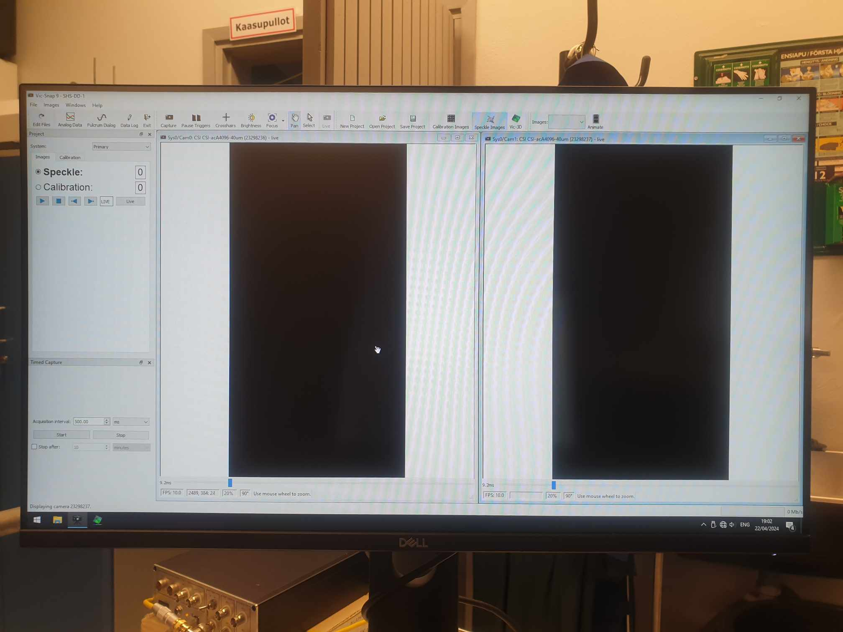

When we first open Vic Snap software, we would see two options, speckle, or calibration options.

* For Speckle option: the cameras would take images taken from the specimen. This is what we choose in this case, since we are sure that the camera has been well calibrated.
* For Calibration option: takes the pictures of a certain fixed speckle pattern (maybe around 30 pictures) and save them. They can be used later to calibrate devices (such as in Vic 3D)

Then, we need to define acquisition intervals, which tells how often the camera should take the image of the specimen. We choose seconds for acquisition interval as it was the unit of time used by the tensile machines, so it is more compatible if we choose seconds for images as well. In this case, the machine would take a picture once every 2 seconds.

After we have turned on the cameras, it is time to set up tensile test options, which is controlled by the TestXpert II software.

## 3.2 Tensile test setup

When we first open TestXpert, we can see all force-displacement curves data of DP800

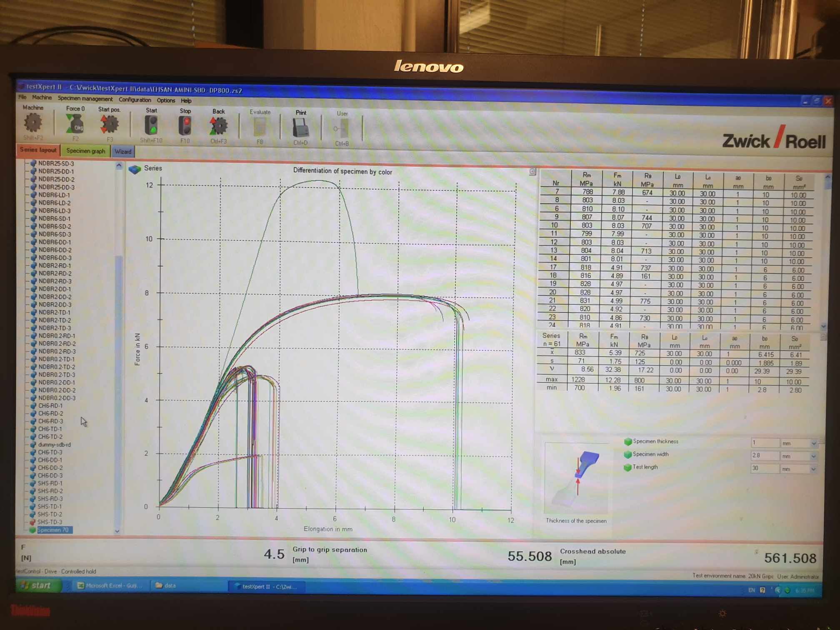

Then we click on the blue Wizard tab to define the settings for tensile test. We open Preload tab

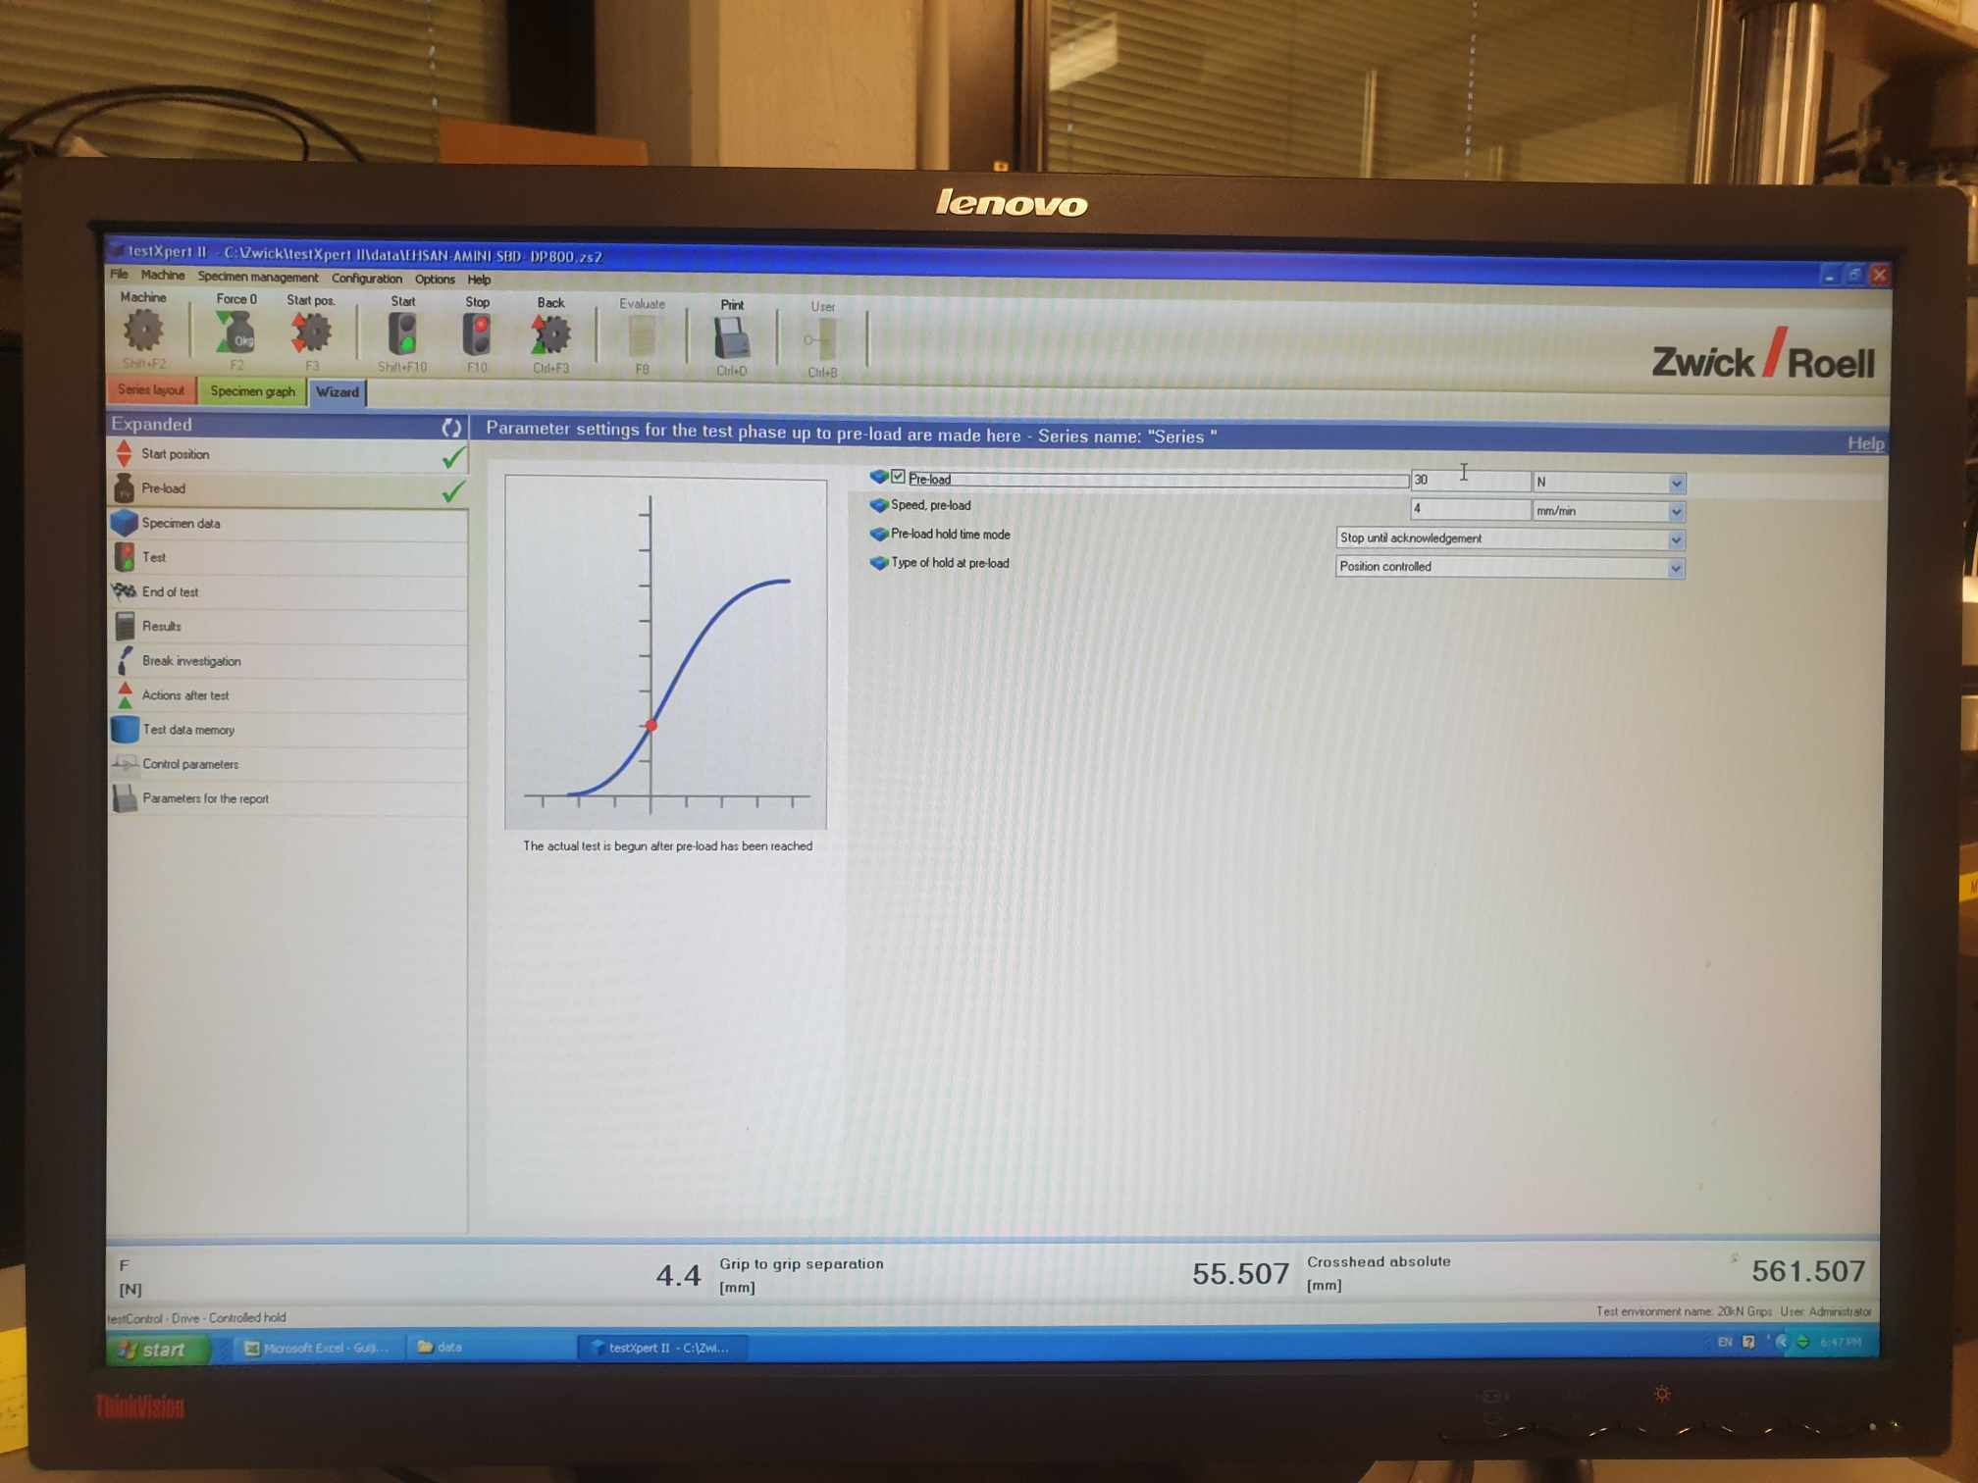

The purpose of the preload is for the machine to tightly grip on the specimen’s gauge firmly. This is because without Preload, there is unwanted data later such as vibration or unwanted displacement of the specimen from its mounted position.

The amount of preload is very important. For SDB DP800, it usually fractures at 800 MPa (or 8kN for SDB specimen). Therefore, we choose a preload of around 15 MPa as preload, which is adequate (compared to 800 MPa, the amount of preload is very negligible). However, for shear geometry, it will break at much lower stress around 600 MPa (or 1.9 kN), so we cannot put 15 MPa as the Preload now would be significant. Based on some calculations, we see that the width of shear geometry is around 2.8 mm and thickness is 1 mm, so area is around 2.8 x 10^-6 m^2, so we put 30 Newton in the box option.

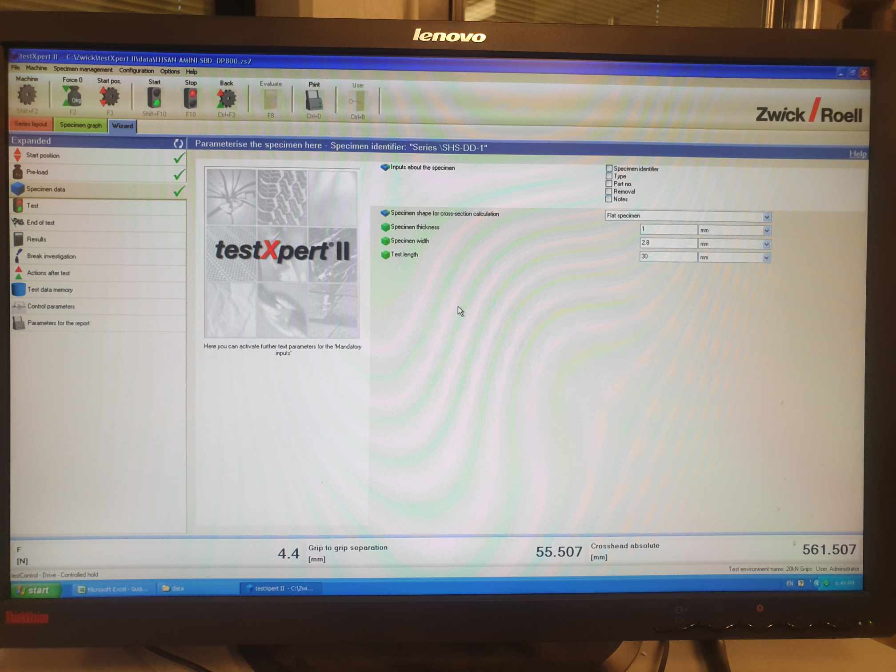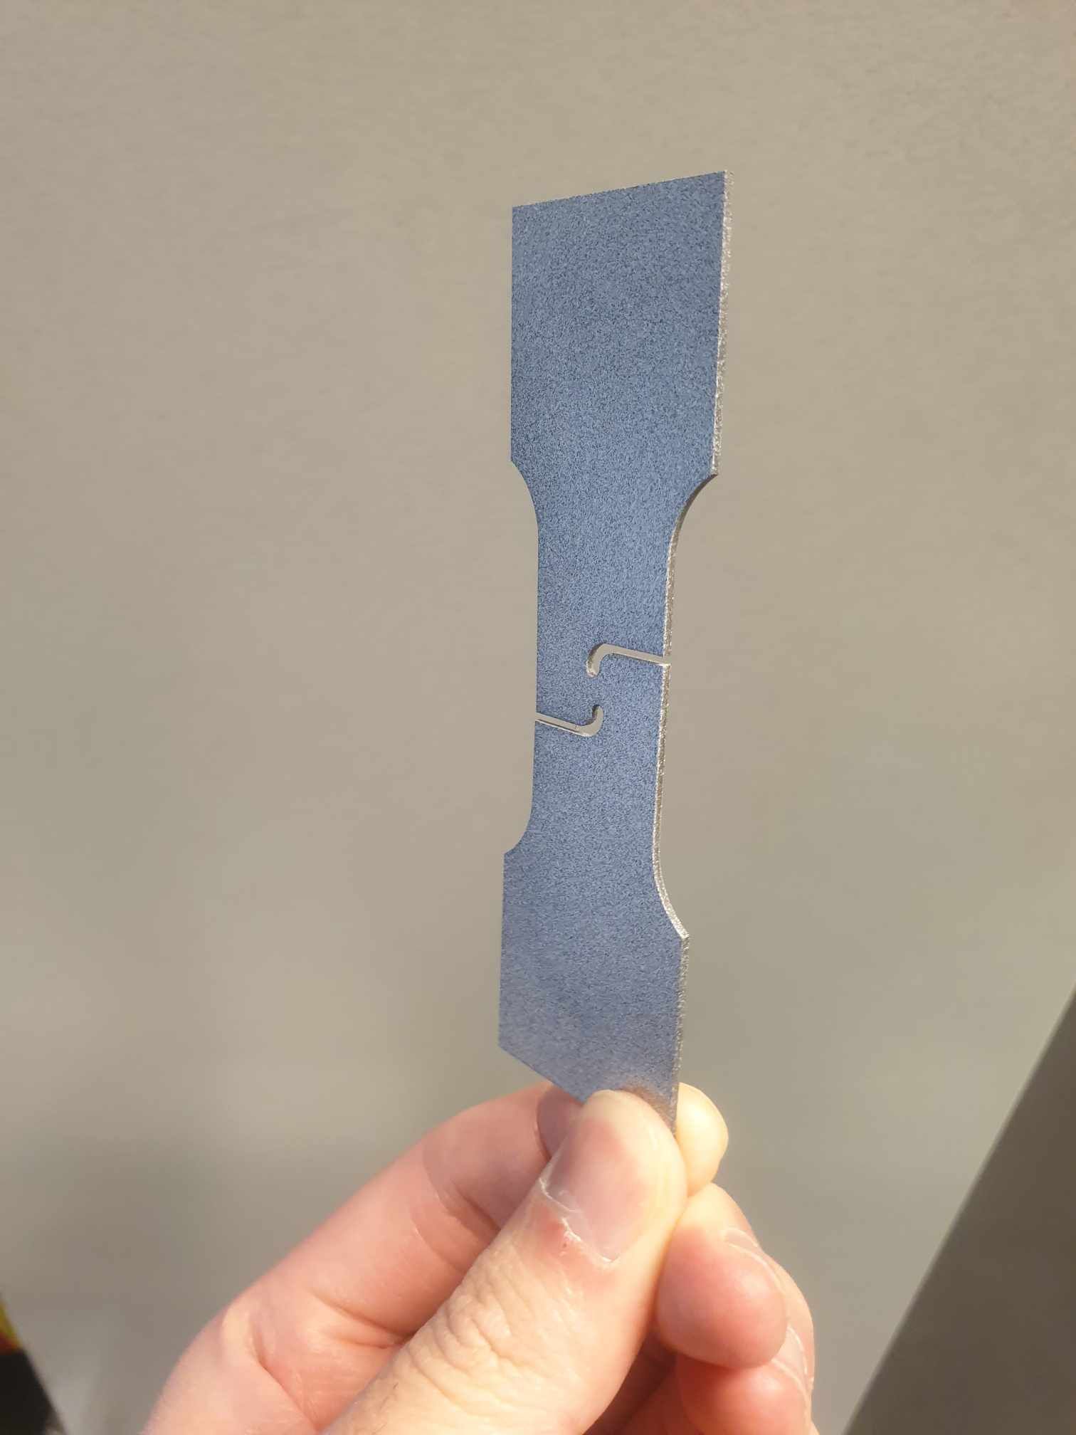

Next, we click on the specimen data tab. In this tab, we only need to define geometry dimensions. For the shear geometry, thickness is 1 mm, width at the middle is 2.8 mm and length is 30 mm.

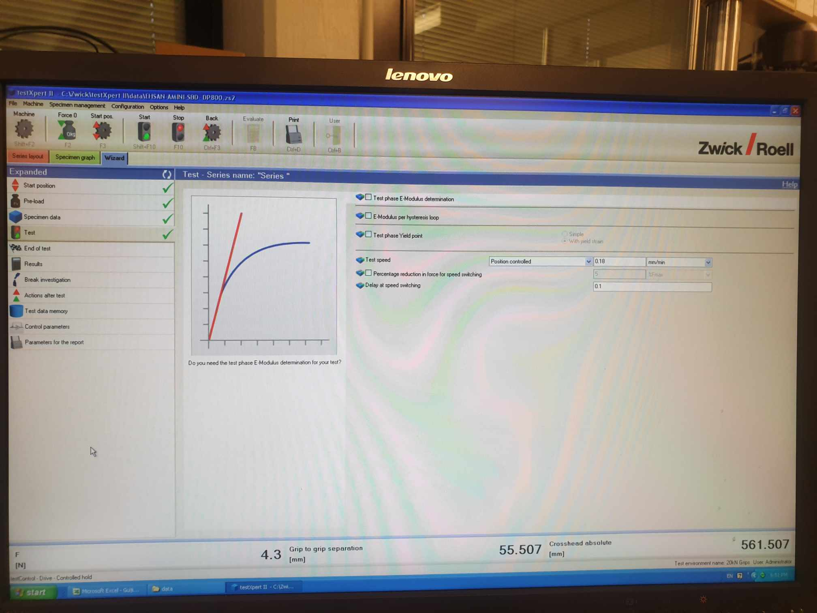

Finally, in the Test tab, the most important information is the Test Speed

For SDB, NDBRx and CHDx specimen, we would use 0.36 mm/min.

For shear specimen, we use 0.18 mm/min (half test speed of other geometries’)

Other tabs (end of test, results, etc), we can let them be their default settings.

## 3.3 Setting up the testing specimen

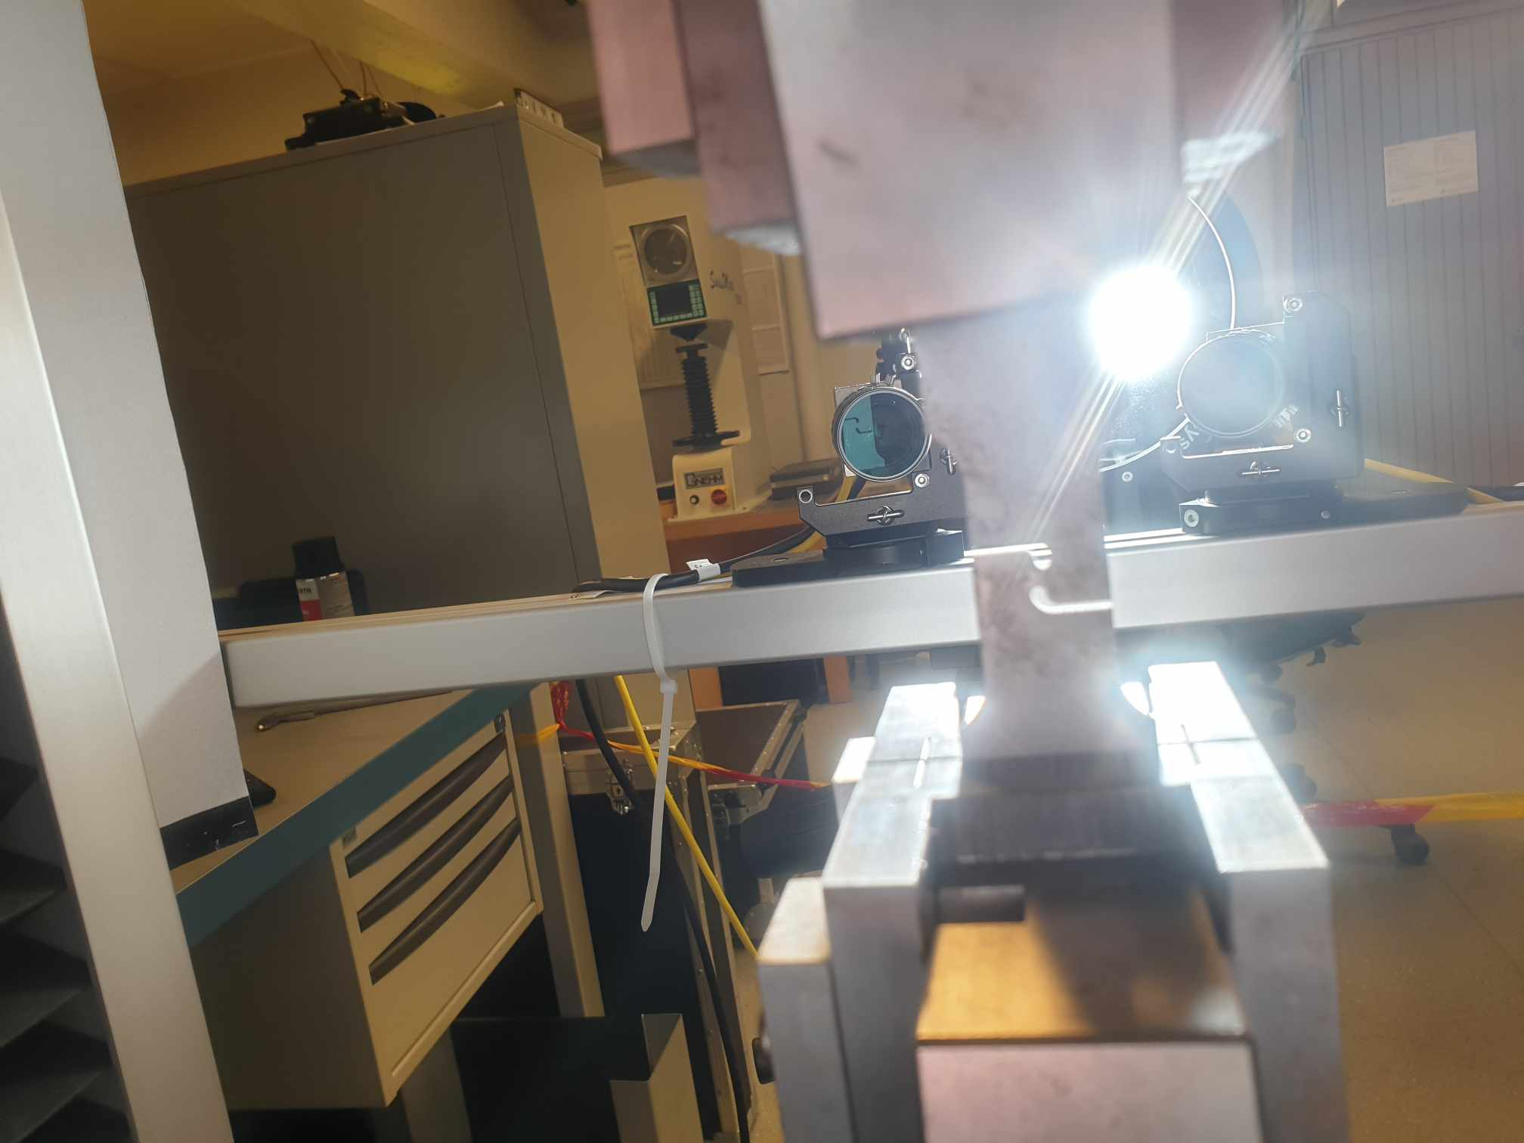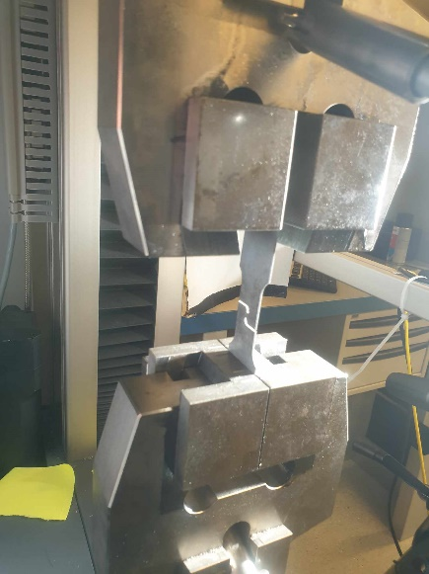

Finally, when we put the specimen into the tensile machine, we should position it in exact symmetric position in both X and Y direction. This is because DIC images expect the specimen to be in exact perpendicular positions for highest accuracy of correlation calculation.

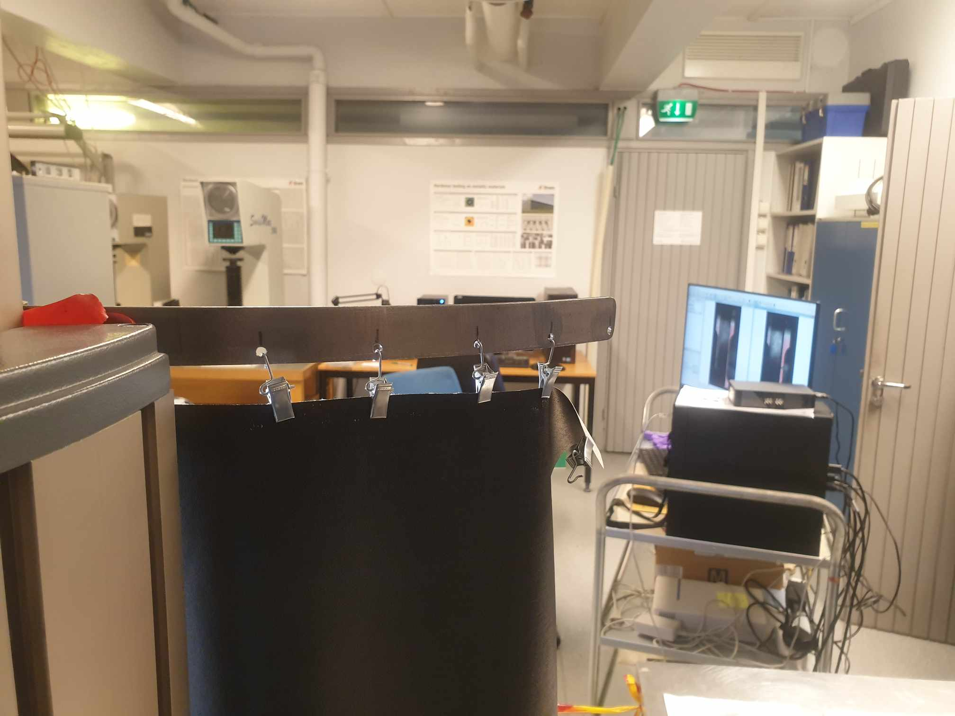

To align better, we can use the perpendicular tool to totally make the specimen positioned vertically. As we fix the position of the specimen, we can also look at the monitor screen to ensure that the perpendicular tool totally covers the gauge portion.

after specimen is totally upright

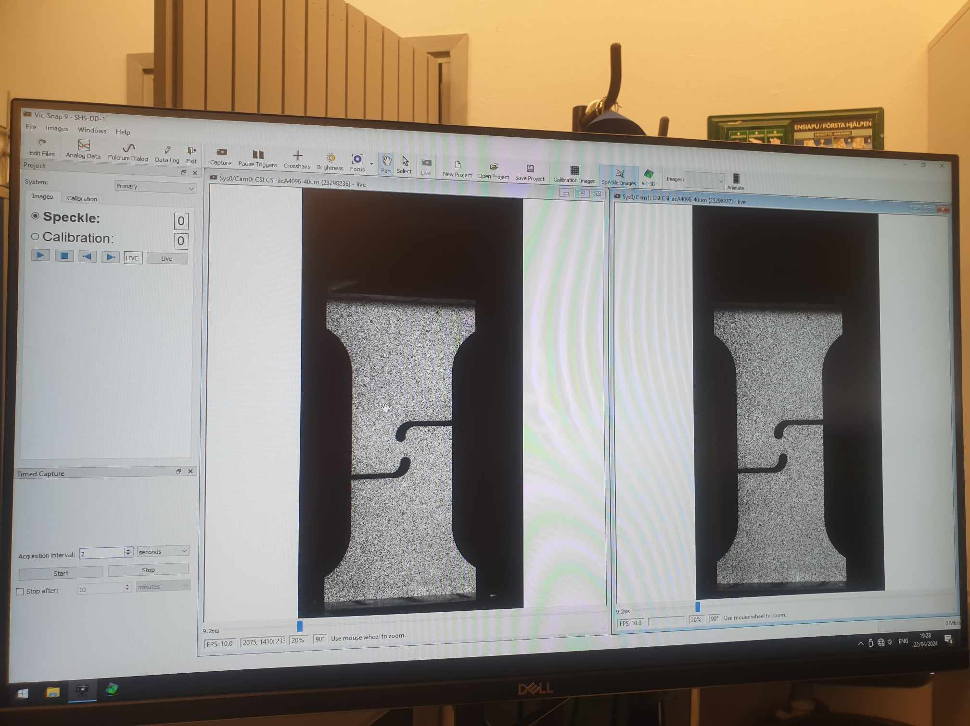

original image: we turn off Light output (red to arrive at the original image)

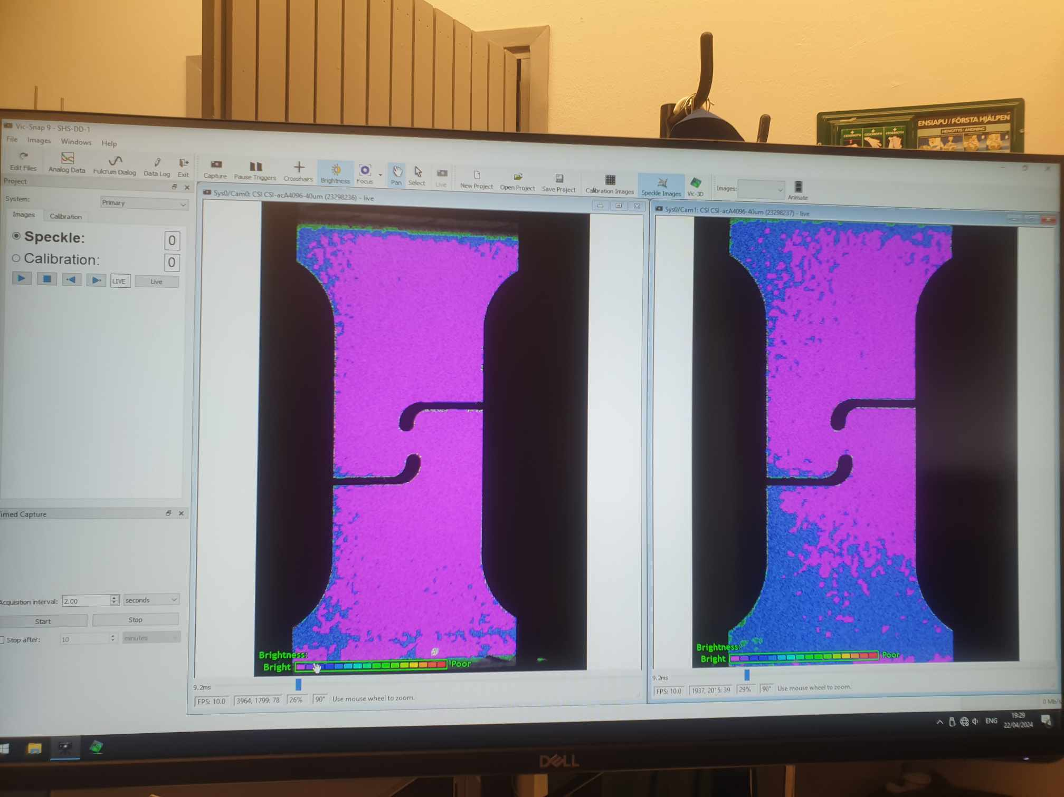

then we press brightness/or focus to see the colors (purple)

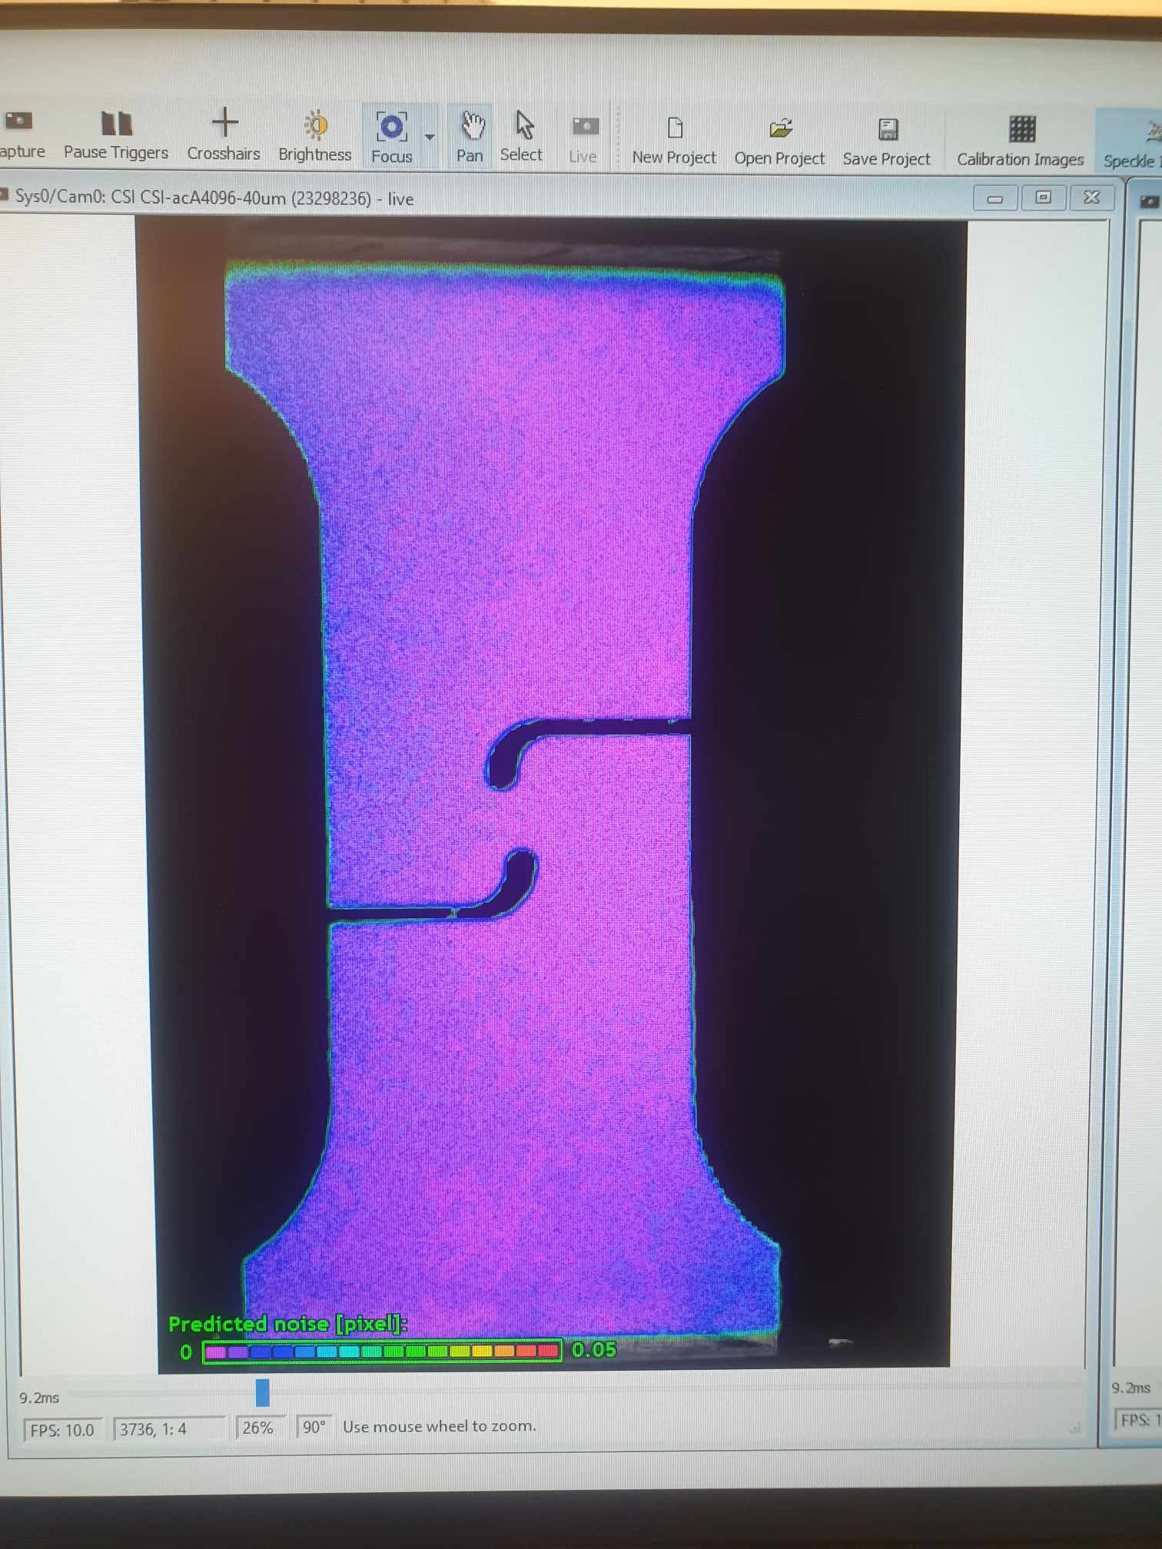

How do we know the quality brightness, using the color map below. Purple and blue usually indicatte good brightness

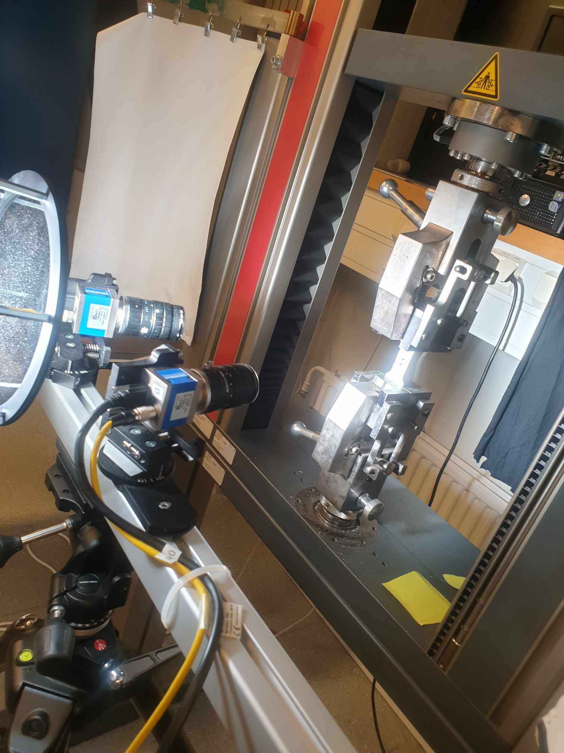

why there are two images on the screen: to capture the thickness varying from the two cameras looking at the specimen. Later on when we postprocessing, the two would be combined together, revealing changes in thickness

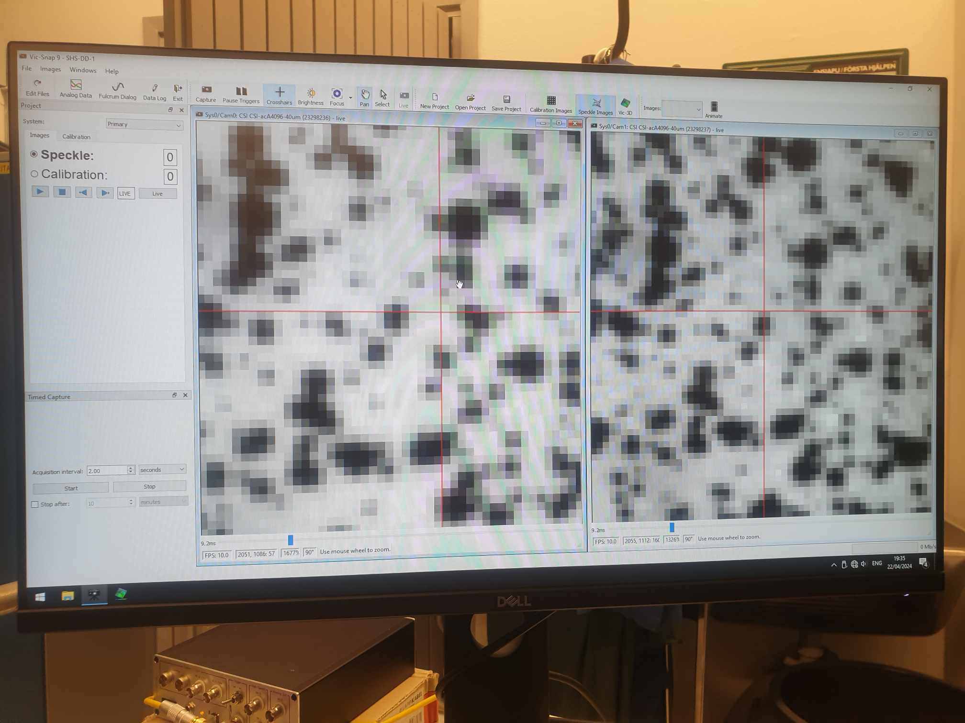

we press crosshairs to check if camera is well calibrated. We continue to zoom until we get at the same point. If the pixel distance is around 4-5 pixels difference then it is okay (one in image) neglectable. Better to be at the same point. However if time is tight or have to do dic test for many settings then we do not have time calibrate.

time to start to click to start the tensile test, and it initially starts the preloading

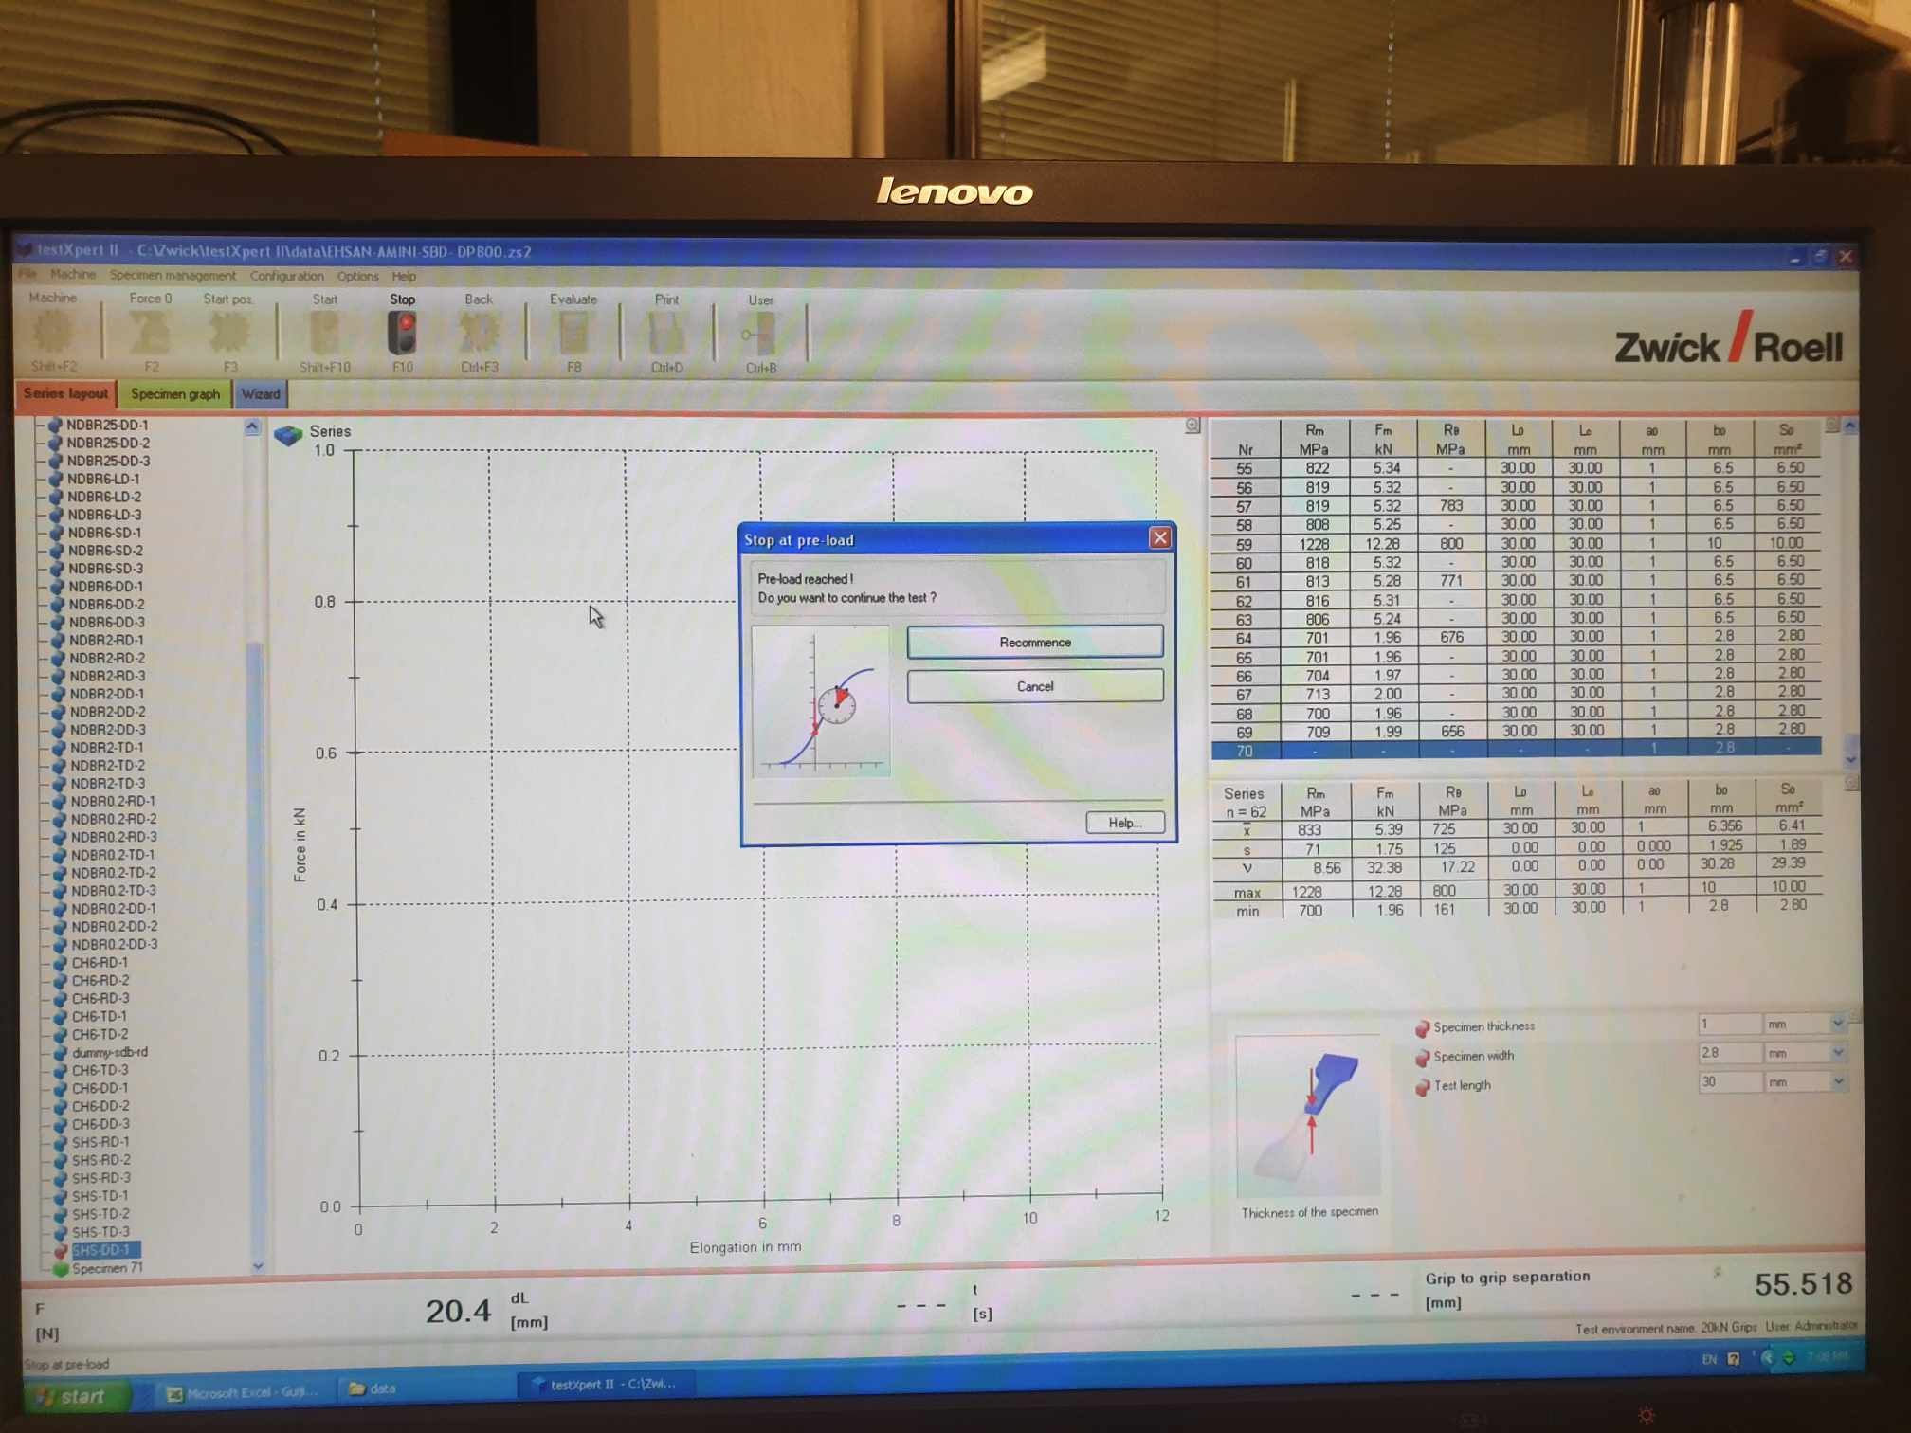

then, DIC machines start to take images (in image right now it is 30 images)

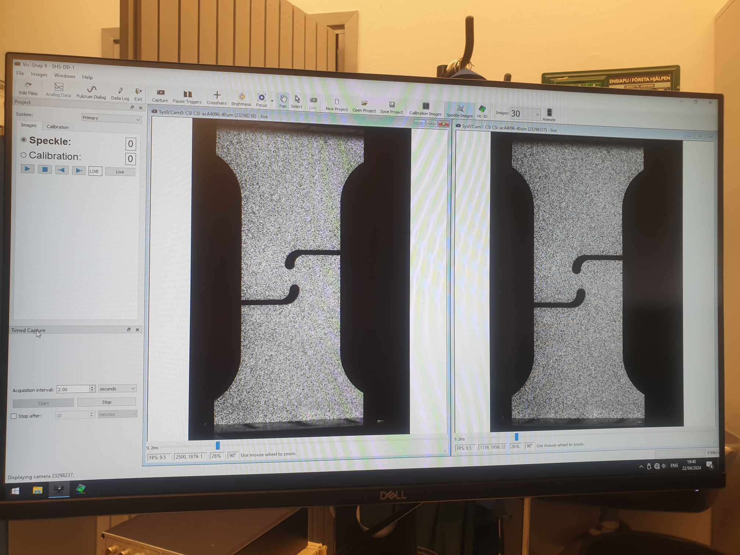

when do we stop? we should wait until the specimen fracture, then click the stop button. or we can choose the stop after option, but it doesnt make sense, so we need to wait for DIC to take images until the specimen fractures, then click the stop button

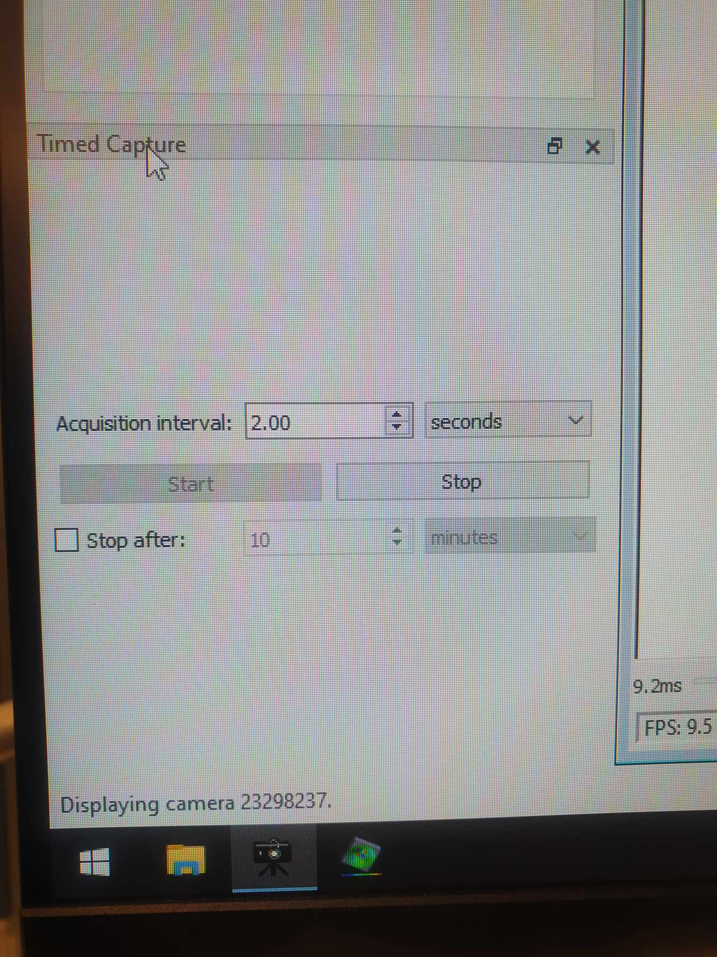

Using DIC, we can obtain

delta_L: L1 - L0

strain: (L1 - L0)/L0

use DIC to obtain L0, L1, delta_L (mainly)

from the tensile machine, we can obtain force. Elongation from the tensile machine is just total elongation between

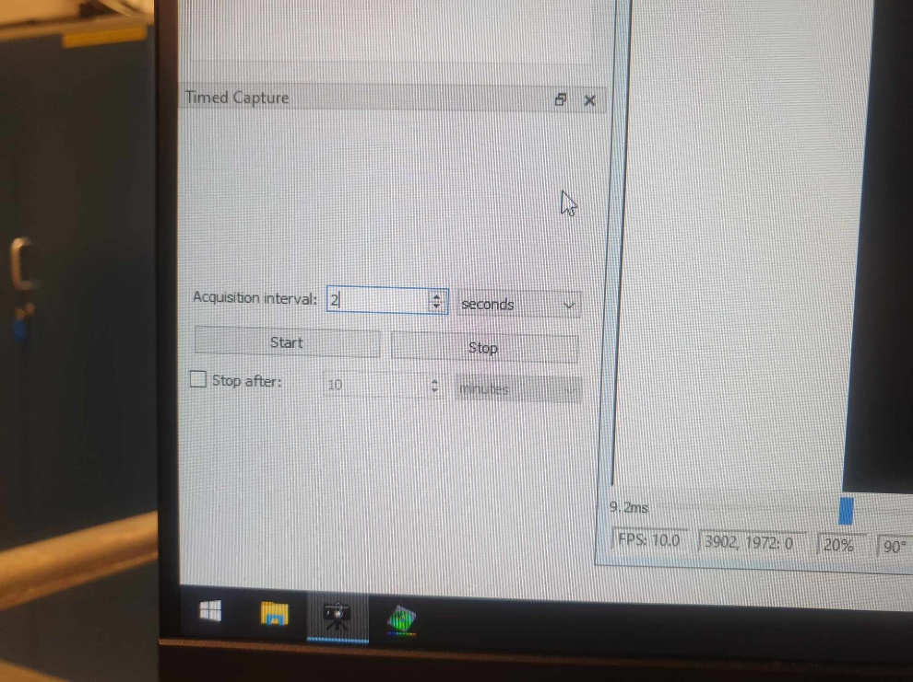

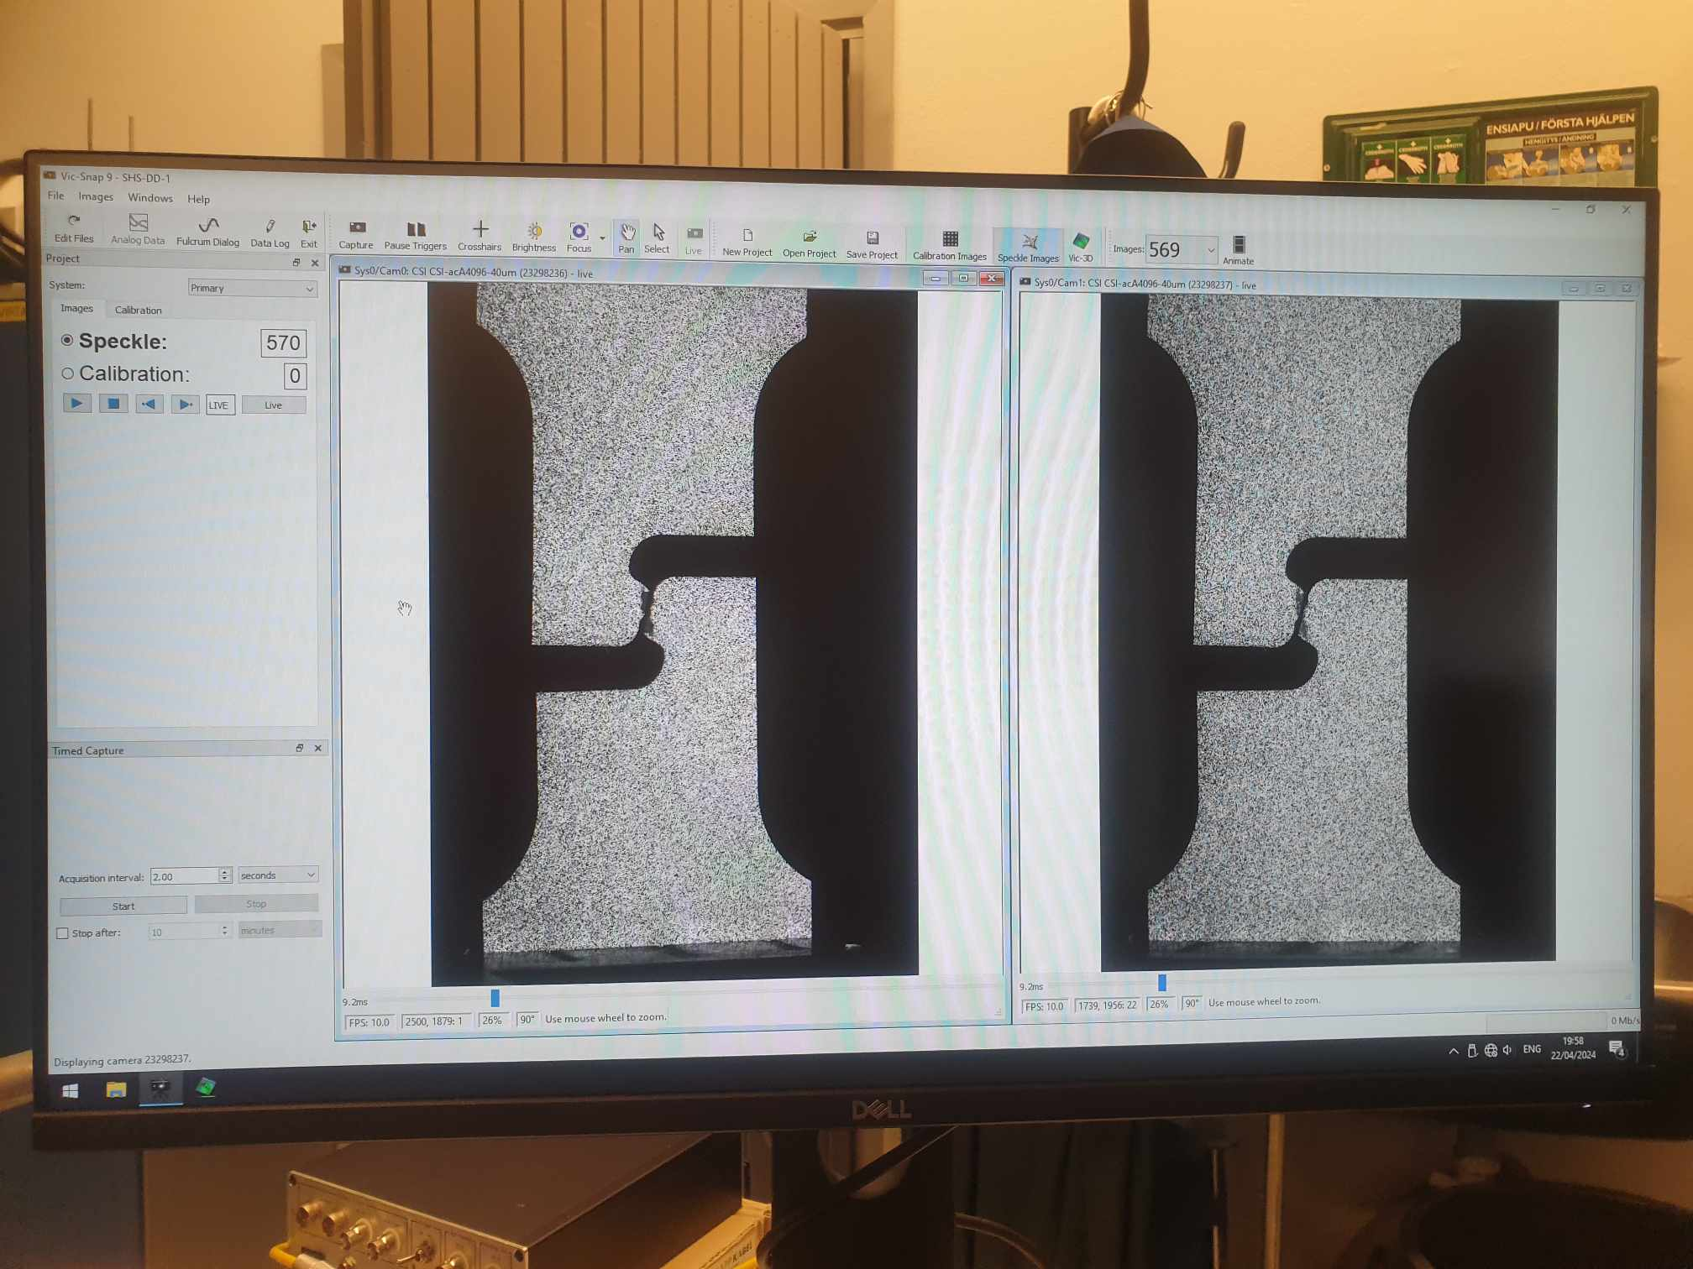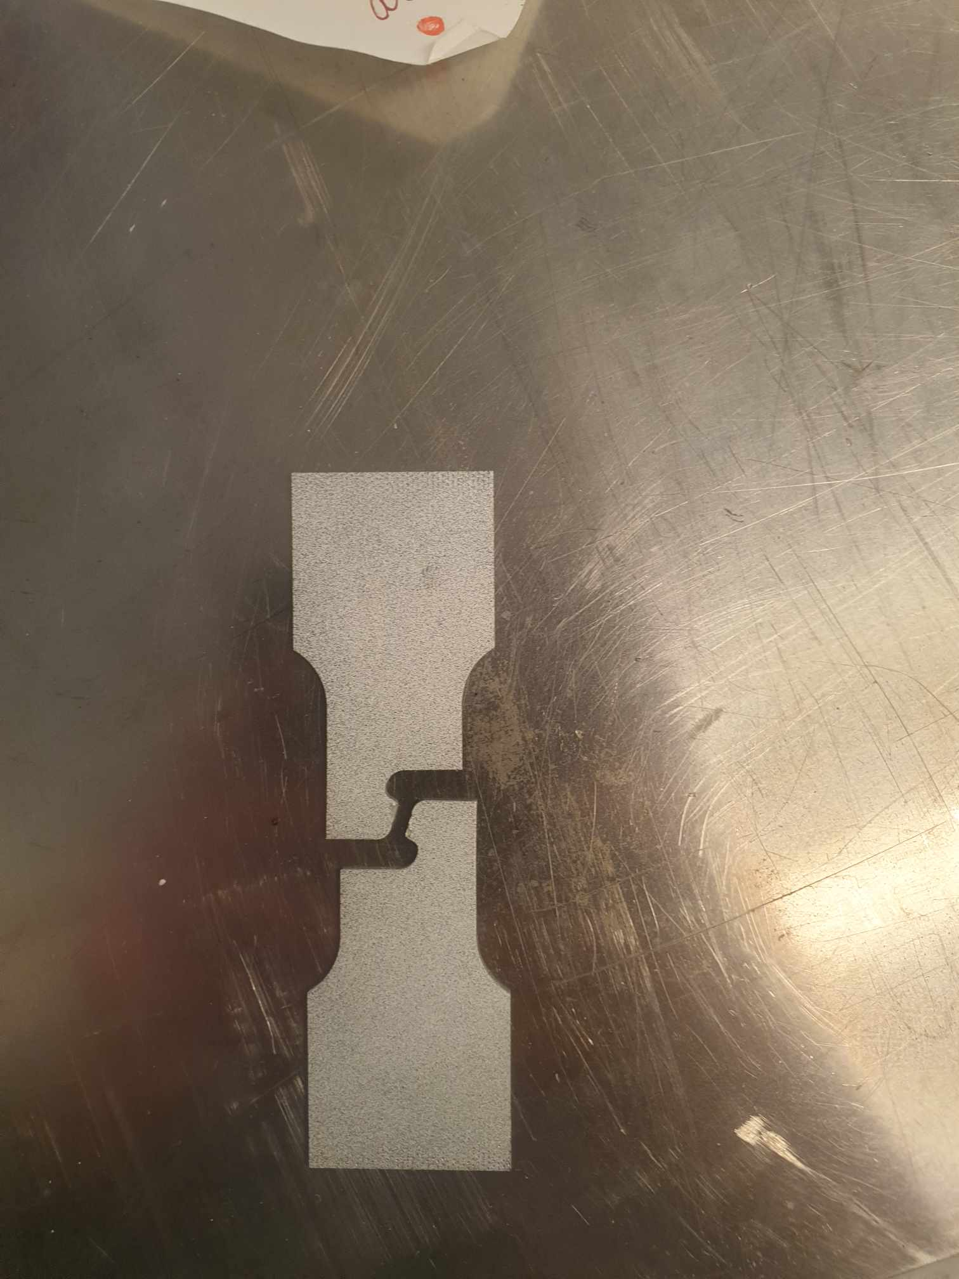

The specimen finally fractures after 569 images. Since each image is 2 seconds, it means shear geometry fractures within 569 x 2 = 1138 seconds

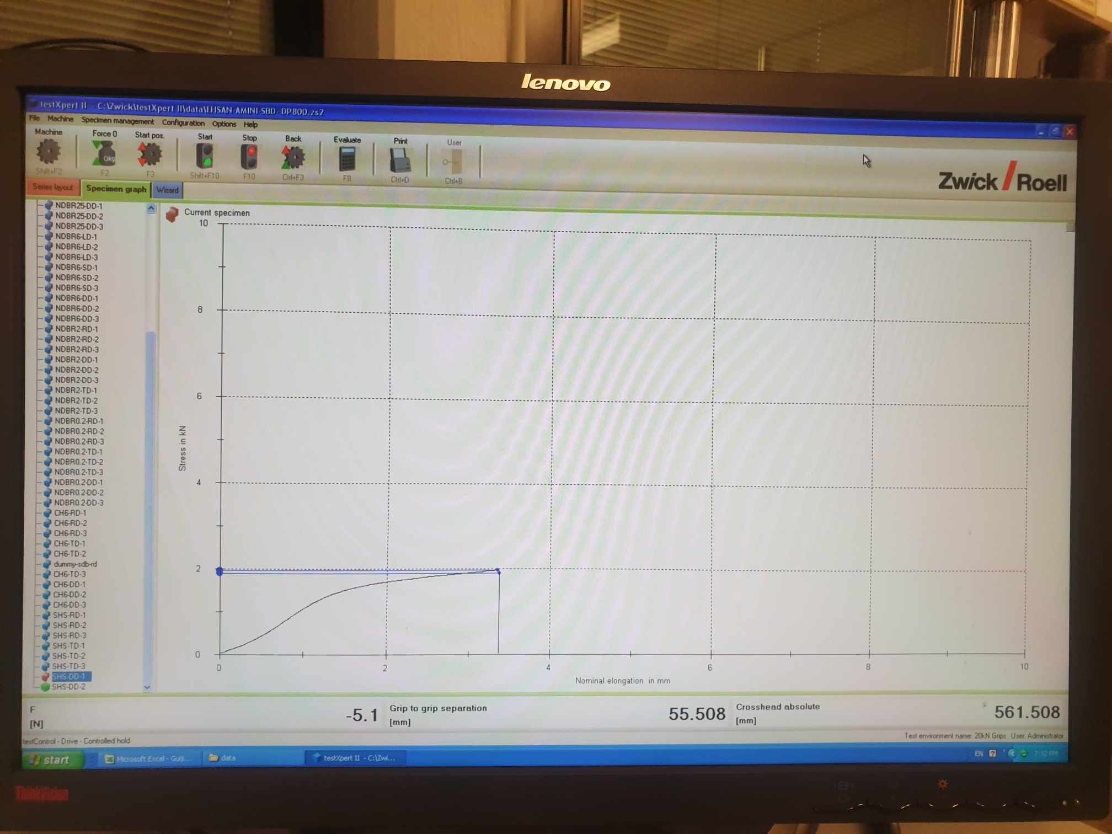

## 3.2 Test execution

Specimens were mounted in the tensile testing machine (TestXpertII software used), ensuring they were aligned perfectly both vertically and horizontally using a perpendicular tool. During the test, we employed different preload values depending on the specimen geometry and expected breakage point, ensuring minimal unwanted data from movements or vibrations. For example, for SDB DP800 the preload was set around 15 MPa, whereas for SHS, it was adjusted to 30 Newton due to its lower breakage threshold.

# DIC testing: Postprocessing stages

Vic Snap 9 is integrated with the tensile testing machine to capture images from the cameras during the test. These images are stored as a series of TIFF files, which maintain standard dimensions for consistency. Subsequently, these images are processed using Vic 3D 9, a software specifically designed for calculating the correlations from the speckle patterns captured on the specimen.

## 4.1 Calibration process

Calibration is crucial to ensure that the two cameras used in the DIC setup are aligned correctly and looking at the same spot on the specimen. This involves positioning a calibration block and taking a series of 30 images, which are then saved for analysis. Calibration is essential every time the camera setup is altered, as changes can impact the accuracy of the correlation analysis. Achieving a calibration score below 0.03 indicates satisfactory camera alignment, with a score of 0.017 serving as validation of the setup's accuracy.

the reason for calibration is that we are going to move the cameras somewhere, and we

The purpose of calibration is to make two cameras looking at the same spot. After that we place the calibration block at that place, and takes a series of pictures (30 pictures), you save them.

lets say that someone new coming to the system and change the camera, and they leave, now our camera is not the same like before.

We should check that camera should look at the same point. If not, we should change the camera position.

the score of 0.017 is just a validation to tell whether the two cameras are good enough. (below 0.03)

4.2 Defining the test area

In Vic 3D, the main test area on the specimen is defined by creating a rectangular selection around the gauge length. It is important to ensure that the rectangle does not touch the specimen's edges to avoid errors in contour calculations. Adjustments might be needed to exclude areas within the specimen that have complex geometries or are empty, such as holes or intricate shapes in shear specimens.

first thing we need to define main test area of this specimen.

click create rectangular

we should create the rectangular on the specimen gauge that is perfectly rectangular where the curves end.

by experience, when we define the rectangles, we shouldnt let the red edge touches the edge of the specimen at all. this is to avoid errors in calculations such as in the contours. So we can move the red edge a little bid inside not touching the edge of the specimen

However, the specimens have some inside geometries that is empty. For example central hole has an empty hole, shear has some complex empty shape inside, and we cannot let dic system to calculate over these empty areas

for SDB, it is simple because there is no empty part

for central hole, it is not difficult, we can use Cut circle

for shear it is very complex, defining cut rectangles, cut circles and curves and so pn it is long process

we need to define the subset, to know the correct value click on the question mark define subset value and it will give a suggestion, then put 23 over there.

## 4.3 Subset and filter settings

In defining the subset for analysis, Vic 3D provides suggestions which can be accessed via the help section; for instance, a subset value of 23 might be recommended. The filtering settings in the analysis should follow the rule that twice the subset size should be less than or equal to the product of the filter size and the step (e.g., 2×23≤11×7).

now everything is ready. we click on the green arrow

in vic3d analysis postprocessing tab, there is the filter size..

the rule of thumb: 2 x subset smaller than or equal filter size x step

2 x 23 smaller than 11 x 7, which is correct.

the reference image is the first image maybe for referencing such as defining the rectangulars and cut circles earlier.

Then we click Run.

## 4.4 Running DIC analysis

Once the setup is complete, the analysis can be initiated by clicking the green arrow in Vic 3D. During post-processing, it's possible to select various contour variables, such as 'eyy' for Lagrange strain in the y-direction. Setting up an extensometer in the software allows tracking of specific points or regions on the specimen throughout the testing process.

## 4.5 Applying extensometers

The initial setup of an extensometer should be along the length where significant displacement is expected, ideally in the center of the test section. This setup helps in measuring changes in length (delta L) accurately across the specimen. Any noticeable vibrations at the end of the test graph could indicate a separation of the paint or speckle from the specimen surface, usually due to large displacements.

then we choose the extensometer

at the first picture we dont have any load (or only the Preload)

since our specimen, the whole y direction test length is 30 mm for all specimen (including sdb).

when we press control, we would even number of milimeters

then we extend extensometer by 30 mm along the y direction of the specimen, and ideally that line should prearbly be the center of the specimen, since that is where the most displacements happen

## 4.6 Data export

The results from the DIC analysis, including point-to-point graphs and other relevant metrics, can be exported to a CSV file for further analysis or reporting. Additionally, videos of the test can be exported, but it might be necessary to remove the extensometer line overlays for clarity.

then we have a point to point graph (yellow)

if there is vibration at the end of the graph, it means the searation of the paint of speckles from the surface possible due to large displacements.

we would switch to extensometers option.

then we can llot delta L (mm) vs Index of the image , we can change it by the Y and X box, then click Add.

E0 is just the name of the extensometer

If we put another extensometer it would be E1 name and so on.

then we click export the csv file

fonally to export video we need to remove the extensometer line

# Results

Using Vic 3D software, the captured data was further analyzed to produce detailed stress-strain curves and other relevant mechanical properties of the material. The data analysis focused on extracting meaningful insights from variations in geometry (SDB, SHS) and directions (RD, TD, DD), ensuring a comprehensive understanding of the material’s mechanical responses.

# Discussion

The DIC testing for DP800 material was conducted meticulously, following rigorous procedures for specimen preparation, equipment calibration, and data acquisition. The detailed speckle pattern, careful calibration, and synchronized data collection enabled the accurate depiction of the material’s deformation under stress, leading to valuable insights into its mechanical properties. This methodical approach ensures repeatability and reliability in our material testing processes.

# Conclusion

# References

[1] International Digital Image Correlation Society, Jones, E.M.C. and Iadicola, M.A. (Eds.)

(2018). A Good Practices Guide for Digital Image Correlation. DOI: 10.32720/idics/gpg.ed1

[2] Guide for uniaxial tension test at room temperature with DIC measurement (DIC manual at the DIC testing lab)